A Community conversation
[Name and/or organization]
[Contact Information – email, website, phone]

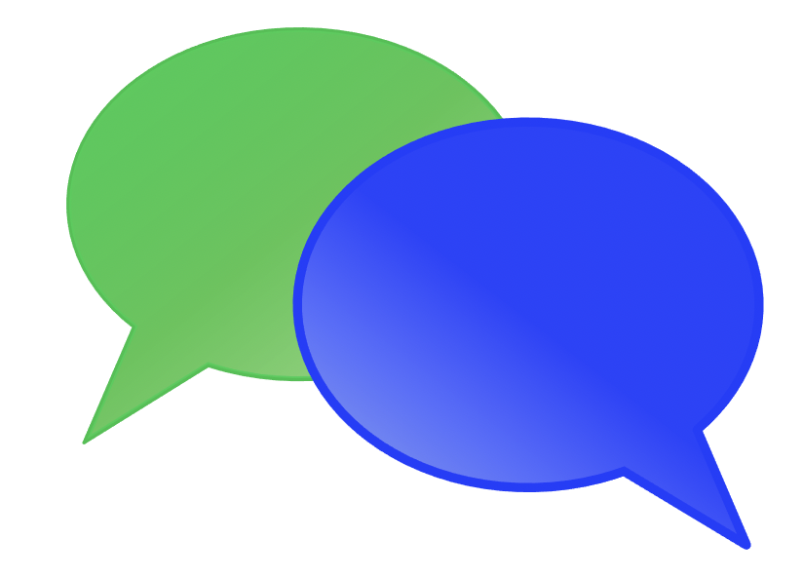  Photo Description: Two overlapping thought bubbles, one green and one blue.  [Event Date]  [Event Time] |  | We invite you to a Community Conversation about how our schools and community can increase inclusion and belonging for youth with disabilities.  - Join us for a community wide conversation as we discuss how to schools and our community can be more inclusive and increase opportunities.  - We want to hear from anyone connected to youth in our community…students, parents, educators, employers, organizations and agencies. All are welcome to attend.  - Accommodations and interpretation are available upon request. Please contact [name and contact information] by [date].

